Algorithms and Programming I
LAB 6
Exercises

1- Write a program that finds the average age of the person(s) who has given occupation.

Note: Don’t take the values of arrays from the user. Assign them in the code.

Example:
Name | Surname | Age | Occupation
Ahmet | Taş | 34 | Lawyer
Ali | Kaya | 29 | Teacher
Ali | Yılmaz | 38 | Doctor
Mehmet | Tarak | 65 | Lawyer
Ayşe | Ak | 58 | Doctor
Emine | Sakız | 26 | Lawyer

string[,] a = new string[,] {{"Ahmet","Taş","34", "Lawyer"},
{"Ali","Kaya","29", "Teacher"},
{"Ali","Yılmaz", "38", "Doctor"},
{"Mehmet","Tarak","65", "Lawyer"},
{"Ayşe","Ak","58", "Doctor"},
{"Emine","Sakız","26", "Lawyer"}};

Input: Lawyer
Output: 41.7

Input: Doctor
Output: 48

2- Write a program that finds the maximum value of the matrix.

Note: Don’t take the values of arrays from the user. Assign them in the code.

Example:
int[,] a = new int[,] {{4, 4, 7, 2, 9, 12},
{0, 5, 7, 16, 3, 5},
{2, 3, 6, 3, 2, 10}};
Output: 16

3- Write a program that prints the content of a two-dimensional Boolean array, using “*” to represent true and “-“ to represent false.

Example:
bool[,] a = new bool[,] {{true, false, false, true, true},
{false, false, false, true, false},
{true, true, true, false, true},
{false, true, false, false, true}};
Output:
* - - * *
- - - * -
* * * - *
- * - - *

4- Write a program that asks for the dimension N (between 1 and 10) and creates a square matrix A as a_{ij} = i + j.

5- Write a program that determines a matrix is a permutation matrix or not.

A permutation matrix is a square binary matrix that has exactly one entry 1 in each row and each column and 0s elsewhere.

Examples:
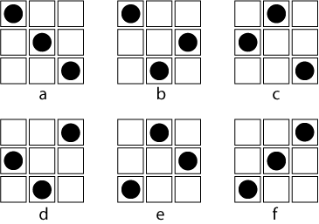
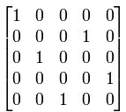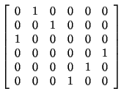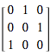

int[,] a = new int[,] {{1, 0, 0, 0, 0},
{0, 0, 0, 1, 0},
{0, 1, 0, 0, 0},
{0, 0, 0, 0, 1},
{0, 0, 1, 0, 0}};
Output: true

int[,] a = new int[,] {{1, 0, 0, 1, 0},
{0, 0, 0, 0, 0},
{0, 1, 0, 0, 0},
{0, 0, 0, 0, 1},
{0, 0, 1, 0, 0}};
Output: false

6- Create a three dimensional array with dimensions 2 x 3 x 4, take data from user for filling the 3D array and check whether each row, column and depth includes at least one zero (0) or not.

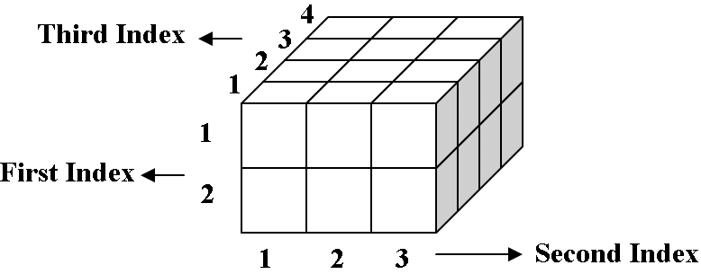

Questions

Upload the answers of the following questions. (November 17, 23:55)

1- NMBR-PUZZLE is a 7x7 matrix puzzle filled with numbers so that the numbers compose a horizontal or vertical path from 1 to 49.
Write a program that prints true if the matrix is valid, otherwise false.

Note: Don’t take the values of arrays from the user. Assign them in the code.

Example:
Input:  33 32 31 2 3 12 13  34 35 30 1 4 11 14  37 36 29 6 5 10 15  38 39 28 7 8 9 16  41 40 27 26 25 18 17  42 45 46 49 24 19 20  43 44 47 48 23 22 21  Output: valid | 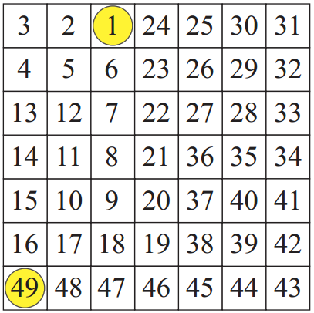  33 32 31 2 3 12 13  34 35 30 1 4 11 14  37 36 29 6 5 10 15  38 39 28 7 8 9 16  41 40 27 26 25 18 17  42 45 46 49 24 19 20  43 44 47 48 23 22 21

Input:
25 24 11 10 9 8 49
26 23 12 5 6 7 48
27 22 13 4 3 46 47
28 21 14 15 2 45 44
29 20 17 16 1 42 43
30 19 18 35 36 41 40
31 32 33 34 37 38 39
Output: valid

2- Write a program that determines a given matrix is a flag matrix or not.

A flag matrix consists of -1s, 0s, 1s, and the sum of each row and the sum of each column is equal to 1.

Example:
0 0 0 1 0 0 0
1 0 0 0 0 0 0
0 0 1 -1 1 0 0
0 0 0 1 0 -1 1
0 1 0 0 0 0 0
0 0 0 0 0 1 0
0 0 0 0 0 1 0

int[,] a = new int[,] {{0, 0, 0, 1, 0, 0, 0},
{1, 0, 0, 0, 0, 0, 0},
{0, 0, 1, -1, 1, 0, 0},
{0, 0, 0, 1, 0, -1, 1},
{0, 1, 0, 0, 0, 0, 0},
{0, 0, 0, 0, 0, 1, 0},
{0, 0, 0, 0, 0, 1, 0}};
Output: true

int[,] a = new int[,] {{0, 0, 0, 1, 0, 0, -1},
{1, 0, 0, 0, 0, 0, 0},
{0, 0, 1, -1, 1, 0, 0},
{0, 0, 0, 1, 0, -1, 1},
{0, 1, 0, 0, 0, 0, 0},
{0, 0, 0, 0, 0, 1, 0},
{0, 0, 0, 0, 0, 1, 0}};
Output: false

3- Write a program that determines a given matrix is a rotated matrix or not.

A rotated matrix is a matrix in which each row is shifted one step.

Example:
5 3 2 0 8 4
4 5 3 2 0 8
8 4 5 3 2 0
0 8 4 5 3 2
2 0 8 4 5 3
3 2 0 8 4 5

int[,] a = new int[,] {{5, 3, 2, 0, 8, 4},
{4, 5, 3, 2, 0, 8},
{8, 4, 5, 3, 2, 0},
{0, 8, 4, 5, 3, 2},
{2, 0, 8, 4, 5, 3},
{3, 2, 0, 8, 4, 5}};
Output: true

int[,] a = new int[,] {{5, 3, 2, 0, 8, 4},
{2, 0, 8, 4, 5, 3},
{8, 4, 5, 3, 2, 0},
{0, 8, 4, 5, 3, 2},
{2, 0, 8, 4, 5, 3},
{3, 2, 0, 8, 4, 5}};
Output: false

